guidelines for authors

paper’s title (all capital, 12pt, bold, centered)

^{1*}First Author, ²Second Author, ³Third Author, etc (10pt, bold, centered)

^{1,2}Afilliation 1 with postal address (10pt)
³Afilliation 2 with postal address, etc (10pt)
E-mail: First Author’s Email, Second Author’s Email, etc (10pt)
*corresponding author (9pt)

Abstract (10pt, bold)

Abstract is written with Times New Roman font size 10, and single spacing. Left and right indent must be 1. The abstract should be written briefly 150-200 words. It includes the research’s purpose, method, result, and the paper’s conclusion. (10pt)

Keywords: up to four key words, separated by commas and put in alphabetical order. (10pt)

- Introduction

These instruction give you the guidelines for preparing papers for International Symposium on Bioinformatics (InSyB) 2017. Use this document as a template if you are using microsoft word 6.0 or later. Otherwise, use this document as an instruction set. Do not change the paper’s format such as font sizes, line spacing or column width to squeeze more text.
The manuscript must be in English and is written with Times News Roman font size 10, single spacing, left and right aligned, on A4 Paper (210 mm X 297 mm) with the top margin 3 cm, bottom margin 3 cm, left margin 3 cm, right margin 3 cm. The width column when using two-columns format is 7.66 cm and the space is 1.27 cm.
The graphic contents and tables should be included in the manuscript between 6 to 10 pages. Heading format should be prescribed as follow : Heading 1 (capital-small, 10pt, bold, left-aligned, and with numbering), Heading 2 (capital-small, 10pt, bold, left aligned without numbering).

- Methodology

The manuscript should be organized in the following order: Introduction (contains background, paper aims or contexts), methodology, result and discussion, conclusion, and references. Acknowledgment (if any) is written after conclusion before the references, and without numbering.

Tables and Figures

Tables are written with Times New Roman font size 8 and no vertical lines in the table. The title should be written with font size 8, left aligned, and above the table without blank spaces. Tables must be numbered and captioned. They must also be refered in the text (Table 1). There is one single space line between the table and the paragraph. Table example is shown in Table 1.

Table 1. Table Example
Data | Accuracy
Data | Testing 1 | Testing 2 | Testing 3
1
2
3

Figures must also be numbered, captioned, and refered in the text (Figure 1). The caption is written in font size 8, left aligned below the figure. There is one single space line between the caption and the paragraph. Figure example is shown in Figure 1.

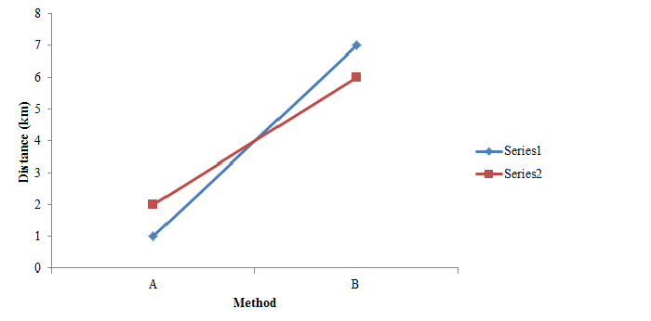
Figure 1. Figure example

Figures can be placed into one column if there are many information need to be showed.
- Result and Discussion

Equation is made using equation function (in M.S. Word) or LaTex equation form. Putting the equation as a picture is not allowed. The equation should be positioned symmetrically on the column followed by number placed into parenthesis. If the writing equation takes more than one line, the number is written on tha last line. Letter used as mathematical symbol must be written in italics such as x.

${\left(x+a\right)}^{n}=\sum_{k=0}^{n}{\left(\begin{aligned}n \\ k\end{aligned}\right)x^{k}a^{n−k}}$ (1)

The equation must be refered in the text with format “equation (1)” except at the beginning of a sentence such as “Equation (1) is...”. One single space line is inserted before and after equation.

- Conclusion

Citation in the text should be written using number in a square bracket [1]. Multiple references is written with ascending order [2], [4]-[6],[9]. Use et al. when cite the work that has more than two authors such as “...Zhao et al. [4]...”.

References

References should be placed in ascending alphabetic order and using numbers in square bracket as seen in the examples. It is presented in a format according to the IEEE style
Books
- B. Klaus and P. Horn, Robot Vision. Cambridge, MA: MIT Press, 1986.
- L. Stein, “Random patterns,” in Computers and You, J. S. Brake, Ed. New York: Wiley, 1994, pp. 55-70.
- R. L. Myer, “Parametric oscillators and nonlinear materials,” in Nonlinear Optics, vol. 4, P. G. Harper and B. S. Wherret, Eds. San Francisco, CA: Academic, 1977, pp. 47-160.
Journal
- Z. Zhang et al., “Paper Title,” Physical Review Letter, vol. 74, pp. 3644-3677, 1995.
- L. Clemen et al., “Quantitative Analysis of Locomative Behavior of Human Sperm Head and Tail,” IEEE Transaction on Medical Engineering, vol. 60, no. 2, pp. 390-396, Dec. 2013.
Conference
- K. Ohnuma et al.,“Surgical Scenario for Laparoscopic Surgery with Timed Automata and Development of Scrub Nurse Robot - Application of Human Adaptive Mechatronics to surgical support system,” Proc. 2nd COE workshop Human Adaptive Mechatronics(HAM), Tokyo, Japan, 2005, pp. 163-166.
Theses, Dissertation
- J. O. Williams, “Narrow-band analyzer,” Ph.D. dissertation, Dept. Elect. Eng., Harvard Univ., Cambridge, MA,1993.
- N. Kawasaki, “Parametric study of thermal and chemical nonequilibrium nozzle flow,” M.S. thesis, Dept. Electron. Eng., Osaka Univ., Osaka, Japan, 1993.
Patent
- J. P. Wilkinson, “Nonlinear resonant circuit devices,” U.S. Patent 3 624 125, July 16, 1990

